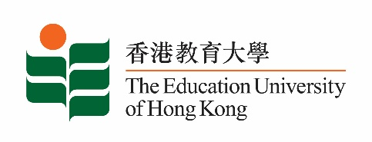
致： 傳媒機構採訪主任 5 May 2023
To : News Editors

香港教育大學2023年 5月8日至 21日可供採訪之活動一覽
The Education University of Hong Kong (EdUHK) Events Calendar for 8 - 21 May 2023
本校誠邀 貴機構派員採訪下列活動。傳媒查詢，請聯絡教大傳訊處（電話：2948 6050）。
You are cordially invited to cover the events below. For media enquiries, please contact the Communications Office at 2948 6050.

以下活動或有人數限制，傳媒請預先向主辦部門登記。
There may be restrictions on the number of participants for the following event(s). Please contact the respective organiser(s) / department(s) for prior registration.

- 教大大埔校園 （新界大埔露屏路十號） / EdUHK Tai Po Campus (10 Lo Ping Road, Tai Po, New Territories)

日期  Date | 時間  Time | 活動  Event | 地點  Venue | 主辦部門及公眾查詢  Organiser &  Public Enquiry | 備註  Remarks
2023-05-08 | 2 pm – 3:15 pm | Music Ensemble Concert | 教大大埔校園  C-LP-11  C-LP-11,  EdUHK Tai Po Campus | 主辦部門 / Organiser:  文化與創意藝術學系  Department of Cultural and Creative Arts  查詢 / Enquiries:  Dr Lo Khin Yee  電話 / Tel:  2948 7259 | 免費入場，  歡迎各界人士參加。Free admission.  All are welcome.
2023-05-16 | 2:30 pm – 5 pm | 粵港澳大灣區基層理財教育研討會  The Symposium of Financial Education for Vulnerable Group in Greater Bay Area  嘉賓 / Guest :  香港社區組織協會副主任 施麗珊女士  Ms Sze Lai-shan  Deputy Director,  Society for Community Organization  姚偉梅教授  Professor Christina Yu Wai -mui | 教大大埔校園  D4-1/F-20  D4-1/F-20  EdUHK Tai Po Campus | 主辦部門 / Organiser:  社會科學系  Department of Social Sciences  查詢 / Enquiries:  譚偉強博士 Dr Tan Weiqiang  電話 / Tel:  2948 8540 | 免費入場，  歡迎各界人士參加。Free admission.  All are welcome.

